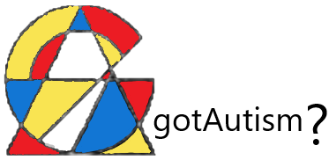

Events

Although April is officially Autism Awareness Month, there are constant events happening all year round.

"Special Day for Special Kids" is a coordinated ongoing group that plans events at local establishments. Events are only available to this group at these times

Upcoming Events planned:
Phoenix Metro Area
- July 31st 2020 – SunSplash at night – Time: 6pm-10pm Location: Country Club/US 60 (Mesa, AZ)
- Aug. 15th 2020 - Picnic at the Park - Time: 8am-12pm Location: Skyline Park Crismon/Broadway (Apache Junction, AZ)
- Dec. 15th 2020 - Zoo Lights – Time: 7pm-closing Location: Phoenix Zoo (Phoenix, AZ)
Tucson Area
- July 20th 2020 - Splash Pad - Time: 9am-12pm Location: Splash Pad (River Rd./Dodge Rd.)
- Aug. 10th 2020 - Reading Room #5- Time: all day Location: Tucson Main Library (Stone Ave/Church Rd.)
- Sept. 15th 2020 - Rodeo Days - Time: all day Location: Tucson Rodeo Grounds
- Oct. 7th 2020 - Zoo - Time: all day Location: Tucson Zoo (Country Club/Speedway Blvd.)
- Oct. 20th 2020 - - Arts & Crafts - Time: 1pm-3pm Location: Tucson YMCA (La Cholla Blvd./Curtis Rd.)

Public Events:
Renaissance Festival (free entry with preregistration @ SARRC)
- Oct. 5th 2020 - Festival Time: 6am-closing Location: Gold Canyon, AZ (Hwy 78)
Annual Race for Research (registration required)
- Nov. 5th 2020 – Race for Research – Time: 6am-closing Location: Tempe Town Lake (Tempe, AZ)
Autism Awareness Walk (registration required)
- Nov. 5th 2020 - Awareness Walk - Time: 8am-closing Location: Tucson's Jacobs Park (Prince Rd./Flowing Wells Rd.)
Autism Fair
- Nov. 12th 2020 - Fair - Time: 7am - 3pm Location: Tucson Fair Grounds (Houghton Rd./I10)

